Grid Computing

A Project Report Submitted
for

Information Technology
By
Anshu Bhatt
(Roll no. 4)
Under the guidance of

Mr. Praveen Kumar Joshi



EVER GREEN SENIOR SECONDARY SCHOOL
(GOVERNED BY EDUCATIONAL WELFARE SOCIETY)
TULARAMPUR – 263139 , DISTRICT-NAINITAL
UTTARAKHAND, INDIA

OCTOBER, 2021

CERTIFICATE

This is to certify that the project entitled “ Grid Computing ” being submitted to Evergreen Senior Secondary School, Haldwani for the project work of INFORMATION TECHNOLOGY is a record of the work carried by MISS. ANSHU BHATT under my guidance and supervision.

Date: 9th October 2021 Supervisor
MR. PRAVEENJOSHI
TGT Computer
Ever Green Sr. Sec. School, Haldwani
Forwarded By:
MR. M.S. PARWAL
Principal
Ever Green Sr. Sec. School, Haldwani

ABSTRACT
Today we are in the Internet world and everyone prefers to enjoy fast access to the Internet. But due to multiple downloading, there is a chance that the system hangs up or slows down the performance that leads to the restarting of the entire process from the beginning. This is one of the serious problems that need the attention of the researchers. So we have taken this problem for our research and in this paper we are providing a layout for implementing our proposed Grid Model that can access the Internet very fast. By using our Grid we can easily download any number of files very fast depending on the number of systems employed in the Grid. We have used the concept of Grid Computing for this purpose. The Grid formulated by us uses the standard Globus Architecture, which is the only Grid Architecture currently used Worldwide for developing the Grid. And we have proposed an algorithm for laying our Grid Model that we consider as a blueprint for further implementation. When practically implemented, our Grid provides the user to experience the streak of lightening over the Internet while downloading multiple files. We are using the concept of grid computing for performing large in complex tasks very quickly and at a short time.
Grid computing is a group of network computers that work together as a virtual super computer to perform last such as analyzing huge sense of data or weather modelling . It has three main components user, control node and provider. It is a type of distributed computing but there is a basic difference between distributed computing and grid computing that in grid computing the work which is distributed among the grid nodes is non interactive.
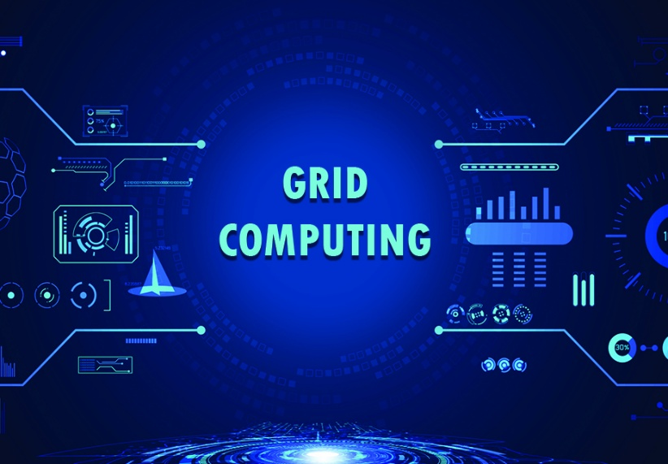

ACKNOWLEDGEMENTS

I would like to express my most sincere heartfelt gratitude and respect to my supervisor MR. PRAVEEN JOSHI, who gave me a golden opportunity to do this wonderful project on the topic “Grid Computing”. I want to express my special thanks to him for his excellent guidance, valuable suggestions and endless support throughout for preparing the report.
This project helps me a lot in gaining adequate knowledge about the topic. I have completed this project after proper analysis and research and I came to know about so many new things.
I would like to express my gratitude and sincere thanks to Mr. M.S. Parwal, Principal of School, and entire faculty who has imparted considerable knowledge to me. I am making this project not only for marks but also to increase my knowledge and intellect development.
Finally, I express my deepest gratitude to my parents for their continuous encouragement, understanding and support .
Thanks again to all who helped me .

Anshu Bhatt

TABLE OF CONTENTS

Chapter | Topic | Page No.
 | CERTIFICATE | 2
 | ABSTRACT | 3
 | ACHNOWLEDGEMENT | 4
 | LIST OF FIGURES | 6
1. | INTRODUCTION | 1
1.1 | INTRODUCTION TO GRID COMPUTING | 1
1.2 | WHAT IS GRID COMPUTING ❓ | 1 - 2
2. | HOW IT WORKS | 3 - 4
3. | GRID ARCHITECTURE | 5
4. | TYPES OF GRID | 6
4.1 | COMPUTATIONAL GRID | 6
4.2 | DATA GRID | 6
4.3 | COLLABORATIVE GRID | 6
4.4 | MANUSCRIPT GRID | 6
4.5 | MODULAR GRID | 6
5. | USES OF GRID COMPUTING | 6 - 7
6. | ROLES OF GRID COMPUTING ORGANIZATIONS | 7
7. | ADVANTAGES OF GRID COMPUTING | 8
8. | DISADVANTAGES OF GRID COMPUTING | 8
9. | SUMMARY AND FUTURE WORK | 9
 | REFERENCE | 10

LIST OF FIGURES

S.No. | Name | Page No.
1. | Computer scientist who discovered the idea of grid computing. | 1
2. | How grid computing works ? | 3
3. | Components and working of grid computing. | 4
4. | Grid architecture. | 5
5. | A woman using the concept of grid | 9

